## Lesson 25 – Activity Sheet

## Getting Started

The first part of this activity is to wire up the **LED** to the pins of the micro:bit. Take your LED and you will see that it has two legs, one is longer than the other, this is the positive leg. It is essential that you get the

Take two crocodile clips and wires and connect them to each end of the LED legs. Take note which one is attached to the positive leg, (this is the longer leg).

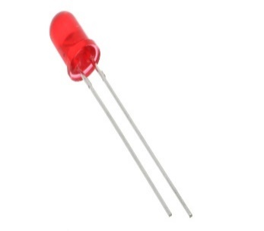

[This Photo](http://commons.wikimedia.org/wiki/File:5mm_Red_LED.jpg) by Unknown Author is licensed under [CC BY-SA](https://creativecommons.org/licenses/by-sa/3.0/)

## **Creating a simple torch**

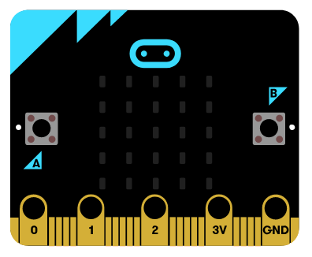

Attach the positive wire to **Pin** 0 and the other leg to the GND Pin. This creates a circuit that is used to power the LED whenever Button A is pressed on the micro:bit.

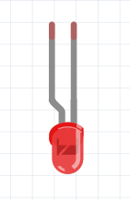

This program builds a simple torch, press Button A and the LED is turned ON. The import code here is the pin0.write_digital(1) which is taken from the microbit.MicroBitDigitalPin **class** which enables you to write values of 0 or 1 to the pin. This is basically turning the pin ON or OFF, which opens or closes the circuit and provides current to the LED. Use the code, pin0.write_digital(1) to write ‘1’ to Pin 0, which turns Pin 0 ON.

Selection is used to respond to the button being pressed, if it is not pressed then the code, pin0.write_digital(0)is used to set the Pin 0 to 0, which turns the LED OFF.

Copy out the program below and write it to your micro:bit. Add the battery pack and you have a portable torch.

from microbit import *

while True:

if button_a.is_pressed():

pin0.write_digital(1)

else:

pin0.write_digital(0)

## Success Criteria

* Wire up the LED correctly
* Write a program to control the LED with Button A
* Try at least one of the Stretch Tasks

## Pro-tip

Use a different coloured wire for the positive leg of the LED as this will help you identify which wire is which. Attaching the positive wire to the 3V pin will provide current to the LED constantly, turning on the LED. You will notice that it is much brighter than when using the Pin 0, why do you think this is?

## Test Time

Ensure that the wires and the LED are connected correctly as shown in the diagram. Remember that the LED has two legs. The longer leg is the positive and must be connected to Pin 0. Write your program to the micro:bit and add the battery pack.

## Stretch Tasks

* Adapt the code so that Button B turns the LED ON
* Edit the code so that the LED stays ON until Button B is pressed
* Write a code so that the LED flashes, this uses ON and OFF and sleeps, see the example code below.

pin0.write_digital(1)

sleep(0.5)

pin0.write_digital(0)

sleep(0.5)

pin0.write_digital(1)

sleep(0.5)

pin0.write_digital(0)

* Wire up two LEDs, one on Pin 0 and another on Pin 1, write the code for Button A to turn on the first LED and Button B to turn on the second.

## Final Thoughts

You have programmed your micro:bit to turn an LED ON, OFF or even flash. LEDs are used everywhere: display, screen and TVs. Your TV screen is made up of millions of LEDs which can display shades of red, green and blue. This combination means that the TV screen can display over 16 million different colours.